Anaconda makes it easy to start working with Python. There are lots of different platforms to use to code in Python but we are going to use Jupyter notebook in this course.

To get Anaconda, simply:

1. [Download](https://www.anaconda.com/products/individual) the latest version of Anaconda for Python 3.8.
2. Install Anaconda by following the instructions on the download page and/or in the executable.

<https://www.anaconda.com/products/individual>

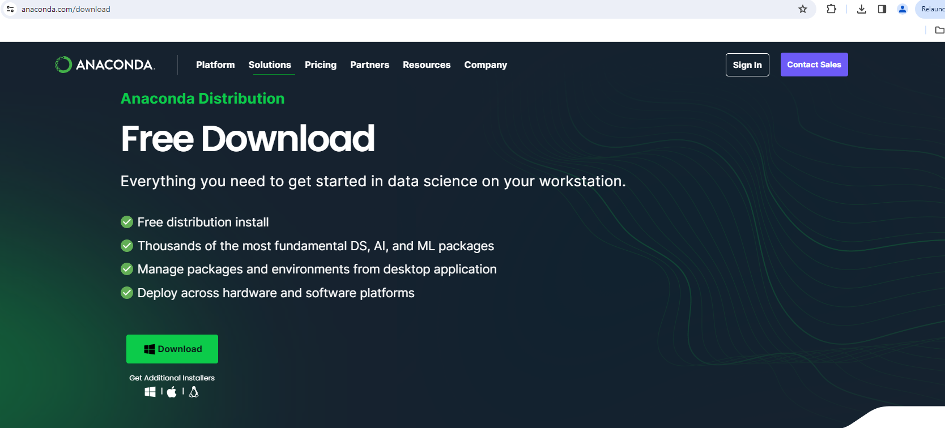

**Step 1: First,**Launch the Anaconda Navigator

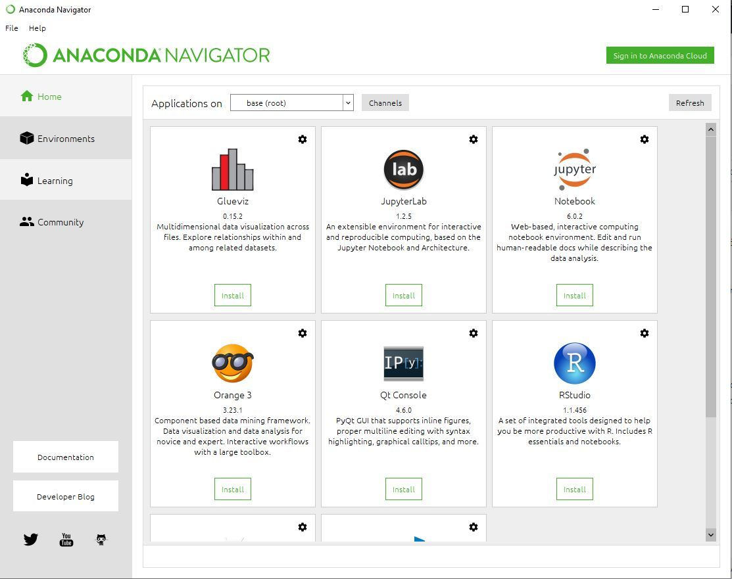

**Step 2:**Click on the Install Jupyter Notebook Button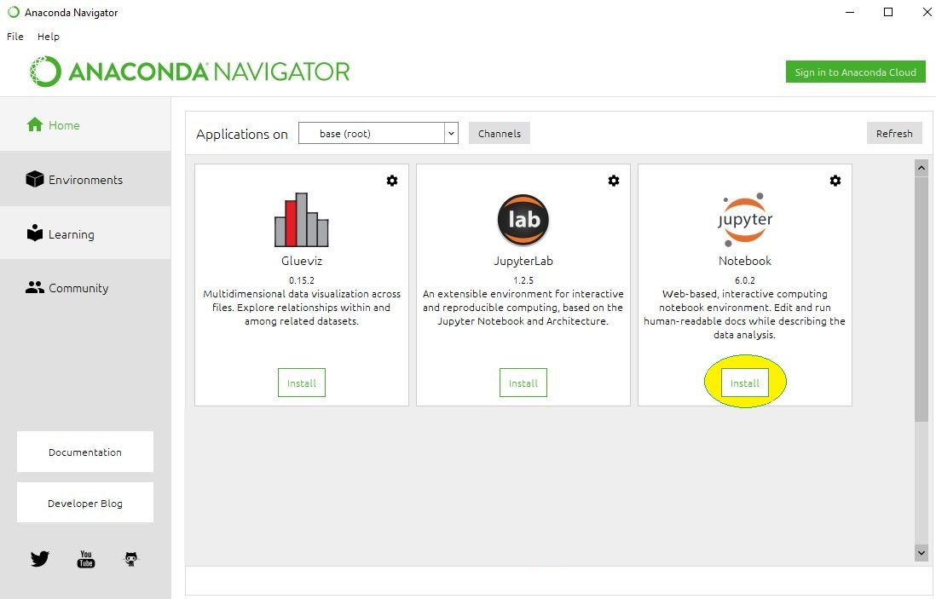

**Jupyter Interface (Dashboard)**

The Jupyter Notebook interface you can see all of the files in your current directory. All Jupyter Notebooks are identifiable by the notebook icon next to their name. If you already have a Jupyter Notebook in your current directory that you want to view, find it in your files list and click it to open.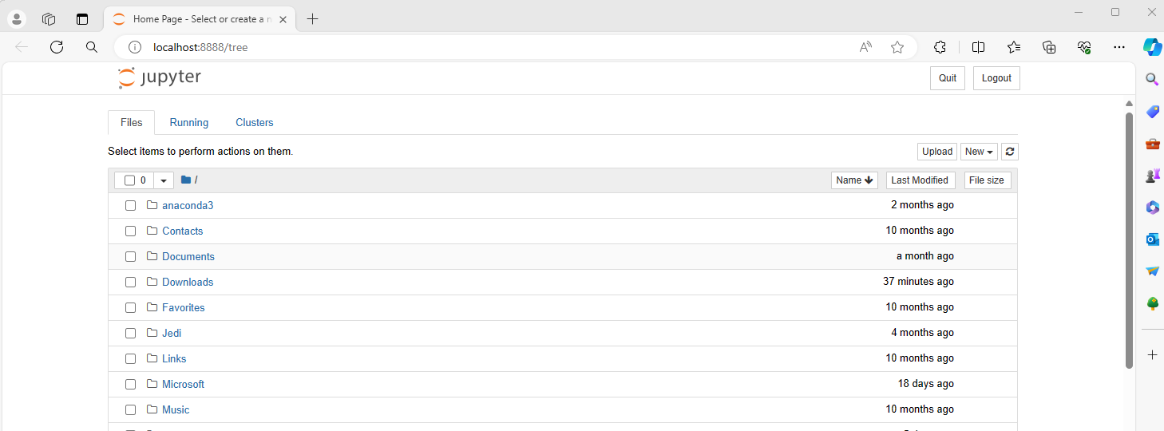

Open a Jupyter Notebook:

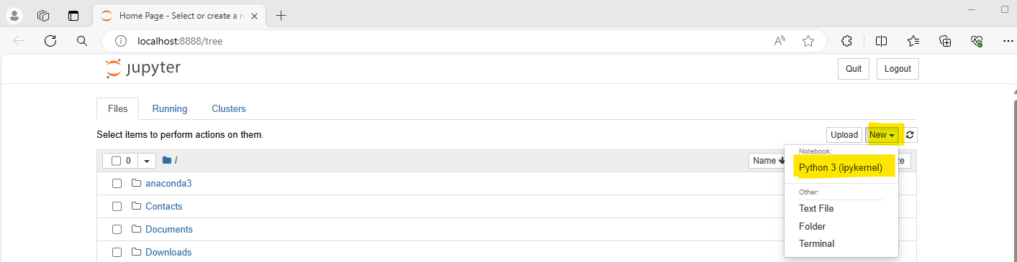

**Inside the Notebook**

When you open a new Jupyter notebook, you’ll notice that it contains a cell.



Cells are how notebooks are structured and are the areas where you write your code. To run a piece of code, click on the cell to select it, then press SHIFT+ENTER or press the play button in the toolbar above.